DFT Applications – Final Exam

Tamoghna Chattopadhyay

Section 1: Sampling and Reconstruction with DFT filter.

Source Code:

% -- -- -- -- -- -- -- -- -- -- -- -- -- -- -- -- -- -- -- -- -- -- -- -- -- -- -- -- -- -- -- -- -

% TITLE: Sampling and Reconstruction with DFT filter.

%

% Purpose: To applying the Discrete Fourier Transform (DFT) to a

% variety of signal processing problems.

%

% Date created: 07/30/2016 Author: Tamoghna Chattopadhyay

% Date modified: rev1 - 08/02/2016

% -- -- -- -- -- -- -- -- -- -- -- -- -- -- -- -- -- -- -- -- -- -- -- -- -- -- -- -- -- -- -- --

% Generate 8192 samples of x(t) at a sampling rate of 100K (10 u seconds).

n = [0:8191];

x = cos( 2*pi*(160/100)*n ) + 0.5 * sin( 2*pi*(180/100)*n );

% Compute the DFT and plot its magnitude for the sampled signal

X = fft(x);

figure(1);

subplot(211),plot( abs(X) );

title( 'Fourier Transform of Original' );

xlabel( 'Frequency (Hertz)');

ylabel( 'Magnitude (unknown) ');

% Insert 3 zeros between each sample

x1 = ins_zeros( x, 4 );

% The spectrum of the up sampled signal

X1 = fft(x1);

subplot(212),plot( abs(X1) );

title( 'Fourier Transform of Zero Inserted' );

xlabel( 'Frequency (Hertz)');

ylabel( 'Magnitude (unknown) ');

% Construct a normalized frequency array ( 0 to 1 matches 0 to fs/2 )

f = [0:length(X1)-1]/length(X1);

% Apply Highpass Filter to the transform

HP_FM = X1 .* HighPass_dft( length( X1 ) )';

% Display the filtered transform

figure(2);

plot( f(1:end/2), abs( HP_FM(1:end/2)));

title('Fourier Transform of the filtered version');

xlabel( 'Frequency (KHz)');

ylabel( 'Magnitude (unknown) ');

% Generate 8192 samples of x(t) at a sampling rate of 400K (2.5 u seconds).

x2 = cos( 2*pi*(160/400)*n ) + 0.5 * sin( 2*pi*(180/400)*n );

% Reconstruct the Original Signal

Xr = 4*ifft(HP_FM);

% Compare the reconstructed signal and the original signal sampled at 400K

figure(3);

plot( x2, 'r:');

hold on;

plot( Xr, 'b-');

title('Comparison of the reconstructed signal and the original signal sampled at 400K');

xlabel( 'Frequency (Hertz)');

ylabel( 'Magnitude (unknown) ');

Function for Inserting Zeroes:

function xe = ins_zeros( x, I )

%

% xe = ins_zeros( x, I );

%

% This function will create an extended version of the signal x

% by simply inserting (I-1) zeros between each sample.

% Create extended set.

xe = zeros( length(x)*I, 1 );

xe(1:I:end) = x;

return;

Function for HighPass DFT Filter:

function H = HighPass_dft( N );

%

% H = HighPass_dft( N );

%

% This program generates a High Pass filter for application to the DFT of a signal.

% The output is an array that is point by point multiplied

% with the dft of the signal.

% The input parameter N is then length of the signal.

n1 = floor( 0.35 * N );

n2 = floor( 0.3875 * N );

n3 = floor( 0.5 * N + 1 );

H = zeros( 1, N );

H( n1:n2 ) = [0:1/(n2-n1):1]; % Up to one

H( n2+1:n3 ) = H( n2+1:n3 ) + 1; % Set At one

H( (N/2+2):N ) = H(N/2:-1:2); % Conjugate Symmetry

return;

Plots:

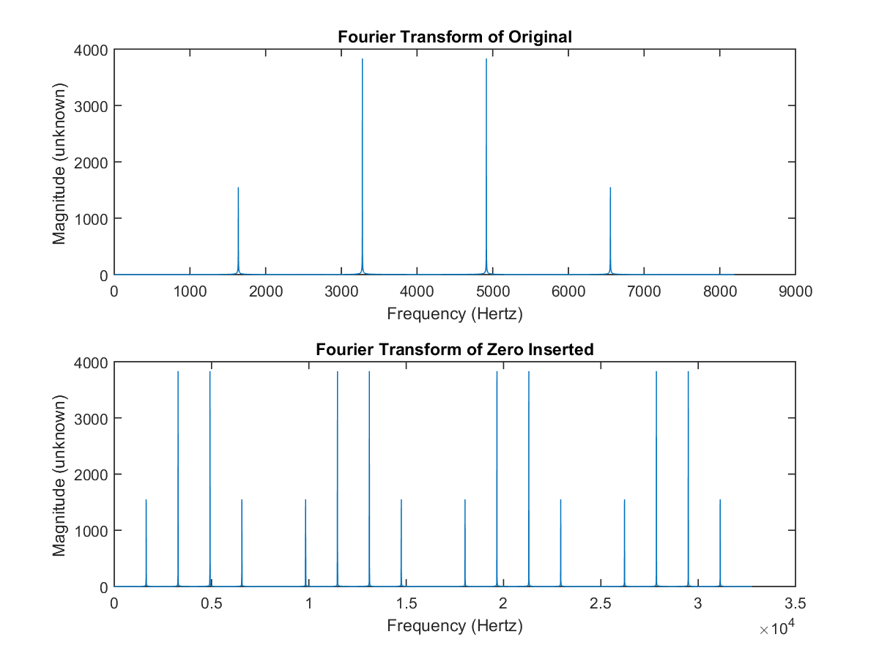

Figure 1

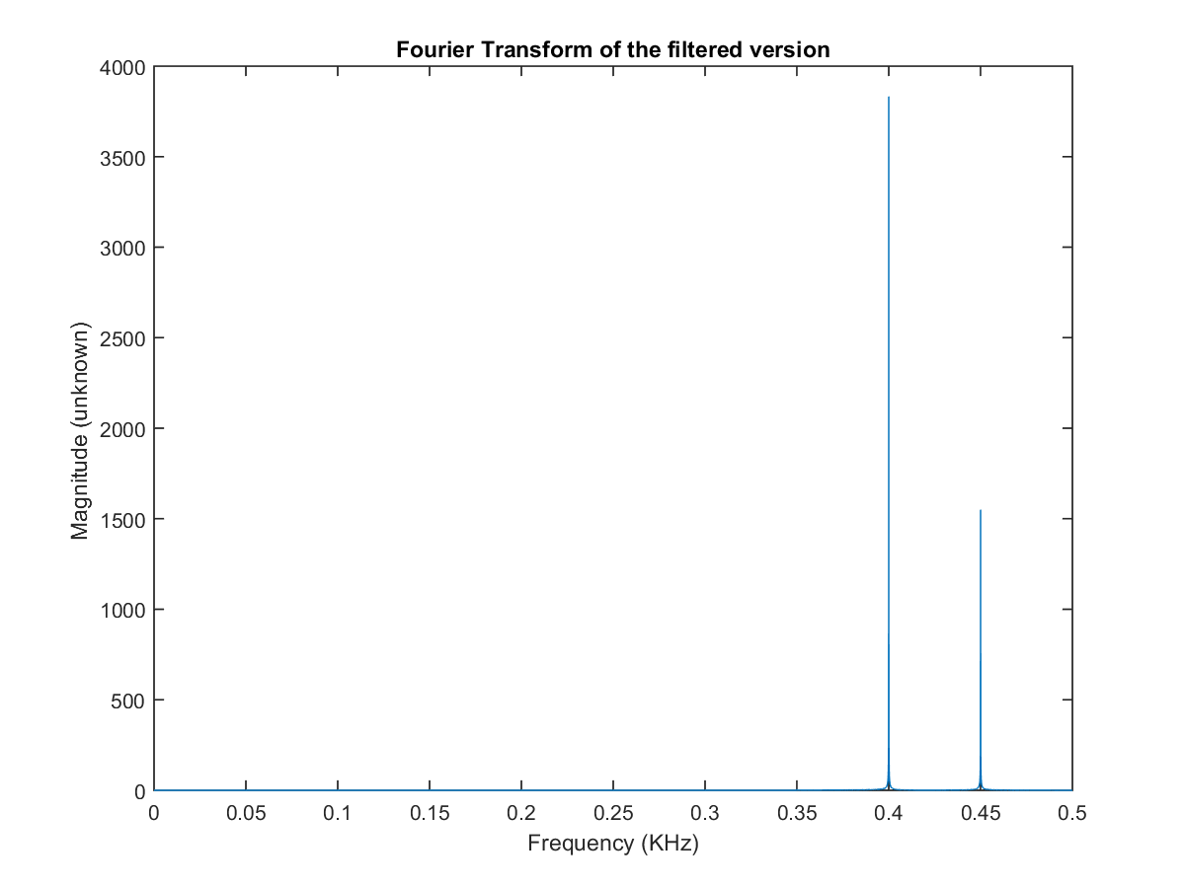

Figure 2

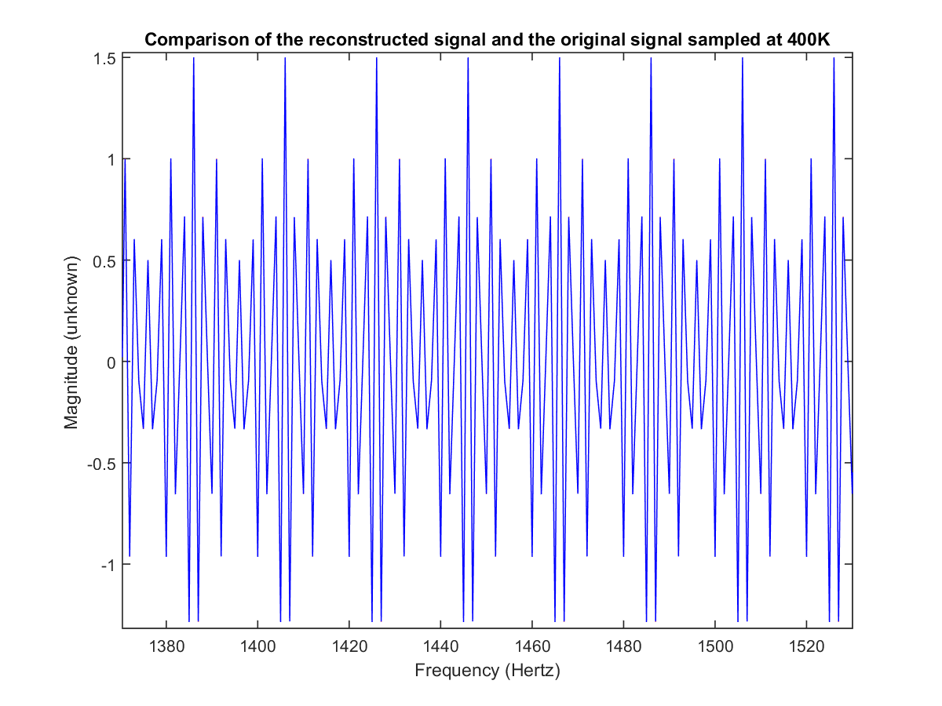

Figure 3

Section 2: Overlap Add.

Source Code:

% -- -- -- -- -- -- -- -- -- -- -- -- -- -- -- -- -- -- -- -- -- -- -- -- -- -- -- -- -- -- -- -- -

% TITLE: Overlap Add

%

% Purpose: To employ Overlap Add in order to process a long signal. A FIR

% bandpass filter with cosine times a hamming window is utilised.

%

%

% Date created: 08/01/2016 Author: Tamoghna Chattopadhyay

% Date modified: rev1 - 08/02/2016

% -- -- -- -- -- -- -- -- -- -- -- -- -- -- -- -- -- -- -- -- -- -- -- -- -- -- -- -- -- -- -- --

% Load the given file

load('DFT_Final.mat');

% Plot the original signal

figure(1);

plot( signal ); % Plot the spectrum

title('Original signal in given MatLab file');

xlabel (' Frequency in Hertz ' );

ylabel (' Magnitude (unknown) ');

% Define the lengths of filter and transform, i.e. 1024 point data

H_Length = length(h);

F_Length = 1024

% Find the fourier transform

H = fft( h, 1024 );

% Filter the data using Overlap-Add

n = 0;

m = 1;

figure(2);

for k = 1:4

SIG = fft( signal( m:m+F_Length-H_Length-1 ),F_Length );

y = ifft( SIG.*H );

if( k==1 )

z = y;

n = F_Length-H_Length;

else

z = [z(1:n) z(n+1:n+H_Length)+y(1:H_Length) y(H_Length+1:F_Length)];

n = n + F_Length-H_Length;

end;

m = m + F_Length-H_Length;

end;

% Plot the result of filtering

figure(2);

plot( real( z ) );

title('Overlap-Add Method of Filter Data');

xlabel( 'Frequency (Hertz)');

ylabel( 'Magnitude (unknown) ');

Plots:

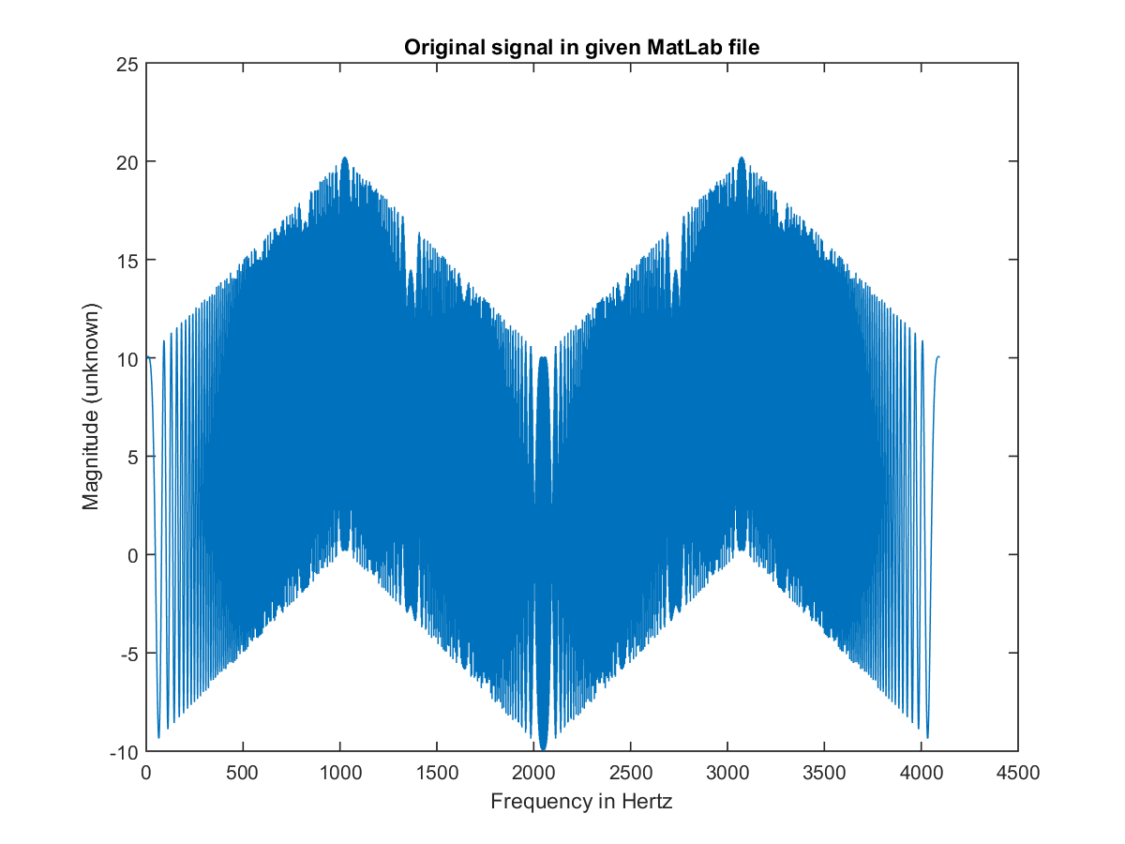

Figure 1

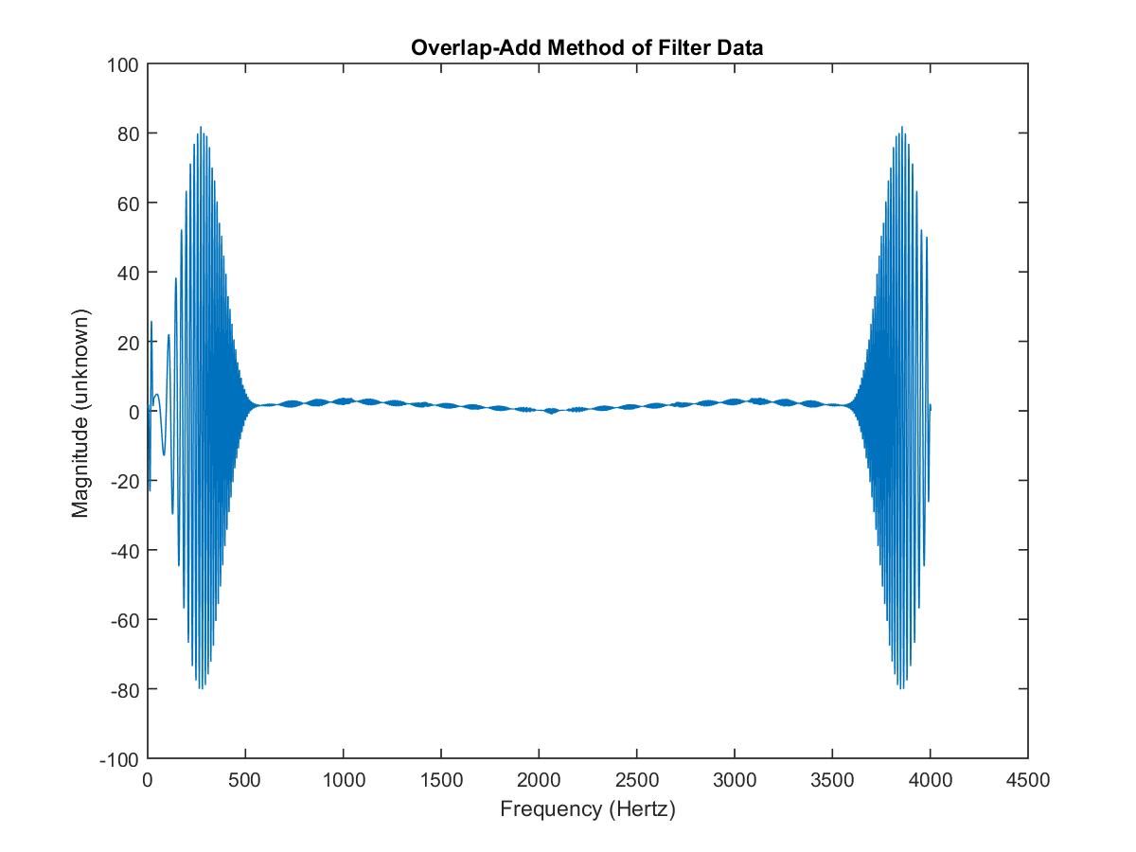

Figure 2

Section 3: Spectral Analysis.

Source Code:

% -- -- -- -- -- -- -- -- -- -- -- -- -- -- -- -- -- -- -- -- -- -- -- -- -- -- -- -- -- -- -- -- -

% TITLE: Spectral Analysis

%

% Purpose: To do spectral analysis on the signal test given in the MatLab

% file provided.

%

%

% Date created: 08/01/2016 Author: Tamoghna Chattopadhyay

% Date modified: rev1 - 08/02/2016

% -- -- -- -- -- -- -- -- -- -- -- -- -- -- -- -- -- -- -- -- -- -- -- -- -- -- -- -- -- -- -- --

% Load the given file

load('DFT_Final.mat');

% Find the frequency of the large main component by iteration

N = 256;

TEST = fft(test,N);

[TMax,NMax] = max(abs(TEST(1:end/2)));

freq = 100e3*(NMax-1)/N;

N = 2*N;

TEST = fft(test,N);

[TMax,NMax] = max(abs(TEST(1:end/2)));

freq = 100e3*(NMax-1)/N;

N = 2*N;

TEST = fft(test,N);

[TMax,NMax] = max(abs(TEST(1:end/2)));

freq = 100e3*(NMax-1)/N;

N = 2*N;

TEST = fft(test,N);

[TMax,NMax] = max(abs(TEST(1:end/2)));

freq = 100e3*(NMax-1)/N;

N = 2*N;

TEST = fft(test,N);

[TMax,NMax] = max(abs(TEST(1:end/2)));

freq = 100e3*(NMax-1)/N

% Plot the fourier transform of the signal

figure(1);

plot( abs(TEST));

title('Fourier Transform of original Signal');

xlabel( 'Frequency (Hertz)');

ylabel( 'Magnitude (unknown) ');

% Subtract out the maximum component

n=0:length(test)-1;

Sub = test - real((1/length(test))*(TMax*exp(i*2*pi*(NMax-1)/N*n))) + ...

conj(TMax)*exp(-i*2*pi*(NMax-1)/N*n);

% Compute its fourier transform

SUB = fft(Sub,N);

% Plot the output of the fourier transform of the subtraction

figure(2);

plot( abs(SUB));

title('Fourier Transform of Signal with subtracted component ');

xlabel( 'Frequency (Hertz)');

ylabel( 'Magnitude (unknown) ');

% Construct a normalized frequency array ( 0 to 1 matches 0 to fs/2 )

f = [0:length(TEST)-1]/length(TEST);

% Apply Highpass Filter to the transform

BP_FM = TEST .* BandPass_dft( length( TEST ) );

% Display the filtered transform

figure(3);

plot( f(1:end/2), abs( BP_FM(1:end/2)));

title('Fourier Transform of the filtered version');

xlabel( 'Frequency (KHz)');

ylabel( 'Magnitude (unknown) ');

Function for BandPass DFT Filter:

function H = BandPass_dft( N );

%

% H = BandPass_dft( N );

%

% This program generates a Band Pass filter for application to the DFT of a signal.

% The output is an array that is point by point multiplied

% with the dft of the signal.

% The input parameter N is then length of the signal.

n1 = floor( 0.1 * N );

n2 = floor( 0.15 * N );

n3 = floor( 0.25 * N );

n4 = floor( 0.3 * N );

H = zeros( 1, N );

H( n1:n2 ) = [0:1/(n2-n1):1]; % Up to one

H( n2+1:n3-1 ) = H( n2+1:n3-1 ) + 1; % Set At one

H( n3:n4 ) = [1:-1/(n4-n3):0]; % Down to zero

H( (N/2+2):N ) = H(N/2:-1:2); % Conjugate Symmetry

return;

Plots:

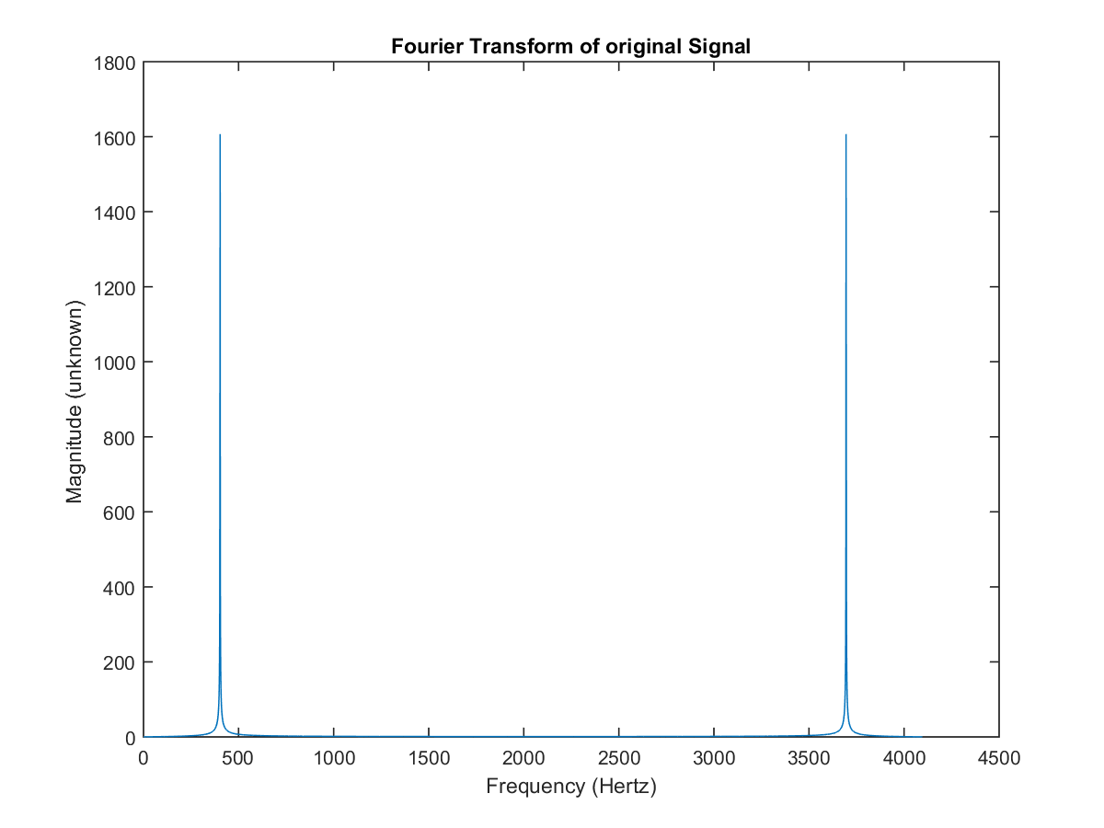

Figure 1

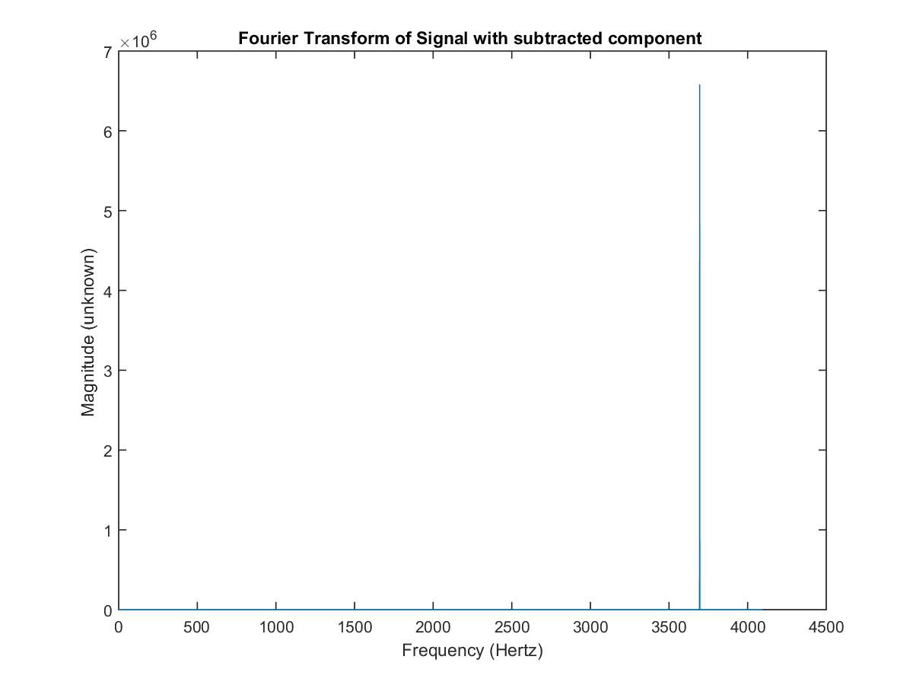

Figure 2

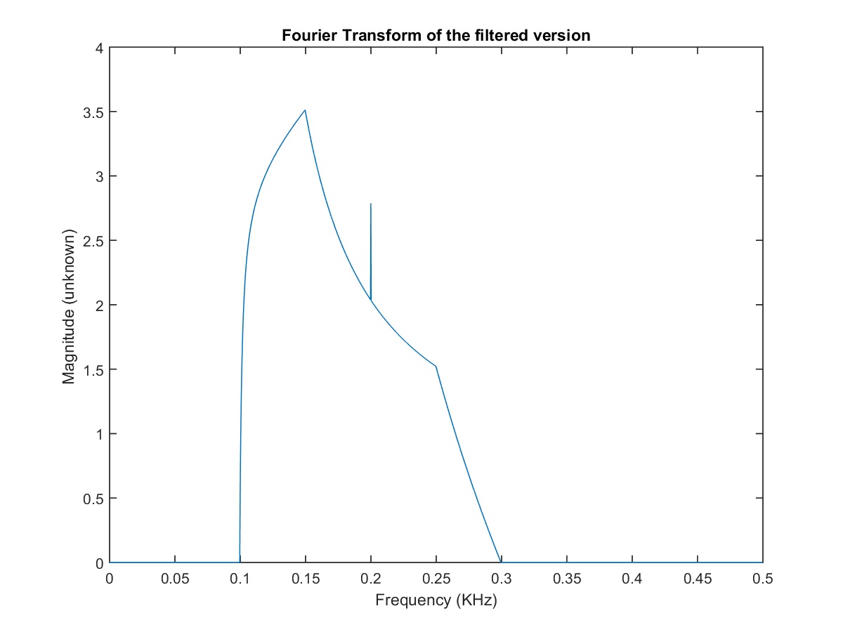

Figure 3